Social Café

Avoca Hotel
Meeting Every Wednesday
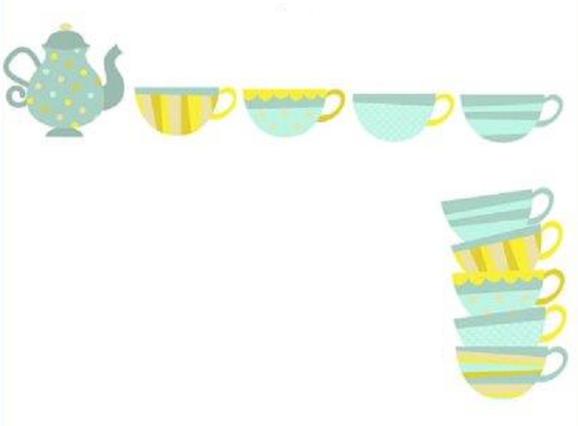
2pm – 4pm
The Social Café is a friendly get together for people to chat, make new friends and learn something new.
Join us for free Tea/Coffee biscuits, selection of Newspapers, Board Games, Jigsaws and the opportunity to get some digital training.

irst Se
Further information contact Nuala/Gemma
028 4461 2311

